Experiment 7:
Aim: Write a Pandas program to create a Pivot table and find the maximum and minimum sale value of the items.
Python code:
import pandas as pd
# Sample Dataset
data = {
"Item": ["Pen", "Pen", "Pencil", "Pencil", "Book", "Book", "Eraser", "Eraser"],
"Unit_Sold": [10, 15, 20, 18, 12, 14, 25, 30],
"Sale_Value": [100, 150, 80, 72, 240, 280, 50, 60]
}
df = pd.DataFrame(data)
print("Original Dataset:")
print(df)
# Pivot Table for Maximum and Minimum Sale Value
pivot = pd.pivot_table(
df,
index="Item",
values="Sale_Value",
aggfunc=["max", "min"]
)
print("\nPivot Table (Maximum and Minimum Sale Value):")
print(pivot)
output:
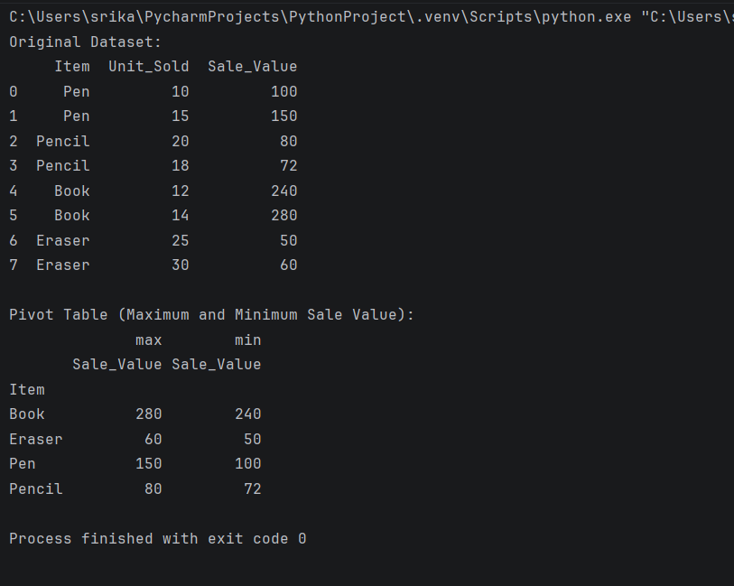
Experiment 8:
Aim: Write a Pandas program to create a Pivot table and find the item wise unit sold.
Python code:
import pandas as pd

# Sample Dataset
data = {
"Item": ["Pen", "Pen", "Pencil", "Pencil", "Book", "Book", "Eraser", "Eraser"],
"Unit_Sold": [10, 15, 20, 18, 12, 14, 25, 30],
"Sale_Value": [100, 150, 80, 72, 240, 280, 50, 60]
}

df = pd.DataFrame(data)

print("Original Dataset:")
print(df)

# Pivot Table for Item-wise Units Sold
pivot = pd.pivot_table(
df,
index="Item",
values="Unit_Sold",
aggfunc="sum"
)

print("\nPivot Table (Item-wise Unit Sold):")
print(pivot)
output:
